## Compare of the speed with multiprocessing or without

Without

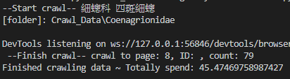

With

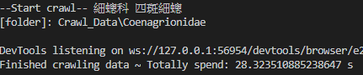

🡪Almost two times faster by using the multiprocessing

With

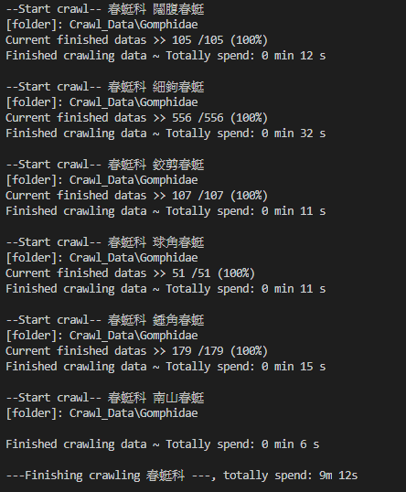

Mainpage

Mainpage

Enter the ID of specific data and output the LAT and LNG

Select the data and plot it on the google map with the data shown in the pop-up table

Update the database

Plot the charts of the choosing species and in the choosing time range

